Assessment 1 – Questioning – Written Assessment
Student Name |  |  | Student ID Number
Unit Start Date |  |  | Unit End Date
Assessment Due Date |  |  | Date Submitted
This cover sheet is to be completed by the student and assessor and used as a record to determine student competency in this assessment task
The assessment process and tasks were fully explained. |  |  |  |  |  |  | Yes / No
I am aware of which evidence will be collected and how. |  |  |  |  |  |  | Yes / No
I am aware of my right to appeal an assessment decision. |  |  |  |  |  |  | Yes / No
I am aware that I can locate the RTO’s Complaints and Appeals Policy and Procedure on their website at (insert website address) |  |  |  |  |  |  | Yes / No
I have discussed any additional educational support or reasonable adjustments I require in order to undertake this assessment with the Student Support Services Officer and Trainer / Assessor, (if applicable). e.g. Student Handbook and Access and Equity Policy (insert website address) |  |  |  |  |  |  | Yes / No
I have access to all required resources? |  |  |  |  |  |  | Yes / No
Cheating & Plagiarism Declaration
Student Declaration: In accordance with the RTO’s Plagiarism Policy, I hereby acknowledge by signing this declaration that I have not cheated or plagiarised any work regarding the assessment tasks undertaken in this unit of competency except where the work has been correctly acknowledged.
NOTE: Student must sign this prior to submitting their assessments to the assessor
Signature |  |  |  | Date: | ______ / ______ / 20______

Assessment Results | Satisfactory |  | or | Not Yet Satisfactory
 | (Please circle the assessment result for this task)
Feedback to Student - Please provide general feedback on the Student’s performance
Student Declaration: - I verify that the work completed is my own and that I was adequately informed of the assessment process prior to commencing this assessment task. |  | Assessor Declaration: - I verify that I have adequately explained and negotiated the assessment tasks with the student prior to commencing assessment.
Student Signature |  | Assessor Signature
Date |  | Date

Context and Conditions of Assessment
This assessment will ensure that the elements, performance criteria, performance evidence and knowledge evidence required and conditions are adhered to demonstrate competency in this unit assessment task.
- Read the assessment carefully before commencing.
- This is an open book assessment and will be conducted at the RTO address.
- Your Assessor will use the assessment criteria in this document and will provide feedback / comment.
- You must answer all the questions in the assessment tasks in your own words and own handwriting.
- This assessment will be required to be completed in 4 hours
- Your Trainer / Assessor will inform you of the due date for this assessment task.
- Your Assessor will grade as either S – Satisfactory or NS – Not Satisfactory for the assessment. In all cases your Assessor will provide you with feedback.
- Only when all assessment tasks have been graded as S – Satisfactory you will be deemed C – Competent in the final result of the unit of competency; if you do not satisfactorily complete all the assessment tasks you will be deemed NYC – Not Yet Competent.
Re-Assessment Conditions
- If the evidence is graded as NS – Not Satisfactory you will be required to re-submit the evidence. In this case, you will be provided with clear and constructive feedback based on the assessment decision so that they can improve your skills / knowledge prior to reassessment.
- Where a ‘NS – Not Satisfactory’ judgement is made, you will be given guidance on steps to take to improve your performance and provided the opportunity to resubmit evidence to demonstrate competence. The assessor will determine and discuss the reasons for NS – Not satisfactory on any of the criteria and will assess you through a different method of assessment e.g. verbal/oral questioning, problem solving exercises.
- You will be notified within 10 working days of undertaking an assessment of their result in achieving competency
- If a student does not complete the assessment, they should notify their trainer as to why they did not complete the assessment and if due to illness, a medical certificate must be produced. “This process is detailed more in the “Training and Assessment Policy and Procedure”
- In the above scenario, student will be given an opportunity for reassessment within 5 working days with no reassessment fee charged.
- Students who are deemed to be Not Yet Competent (NYC) will be provided with information identifying the areas in which they failed to achieve competency. Students will then have the opportunity to repeat the assessment task within 5 working days of notification with no reassessment fee charged.
- If a student is deemed NYC in the reassessment or if the student did not approach the RTO’s within five working days with a valid reason for not availing themselves of the reassessment opportunity, then those students will be given a final chance to re-sit the assessment and will be charged at $200.00.
- After this no further reassessment attempt will be provided to the student and the student will be required to repeat the whole unit with full fee for the unit as per the fees policy of the RTO’s. The student will be made aware of the impact of repeating the unit may have on their student visa.
- If a student is found to be cheating or plagiarising their assessment, a $200.00 reassessment fee will be charged for reassessing the assessment within 5 working days.
- If the student is found to be plagiarising or cheating again after conclusion of the Intervention meeting with the Course Co-ordinator, the matter will be referred to the CEO / Operation Manager which may result in the suspension or cancellation of their enrolment
- The RTO has intervention strategies, including student support services available to enable students to complete qualification in the expected time frame. Students at risk of not completing within this time frame are identified as early as possible and an intervention strategy is put in place.
The RTO will ensure access to:
- automotive repair workplace or simulated workplace
- workplace instructions
- manufacturer braking system specifications
- two different vehicles or machinery with disc and drum braking systems requiring servicing
- tools, equipment and materials appropriate for inspecting and servicing braking systems.
Evidence to be submitted by the student: -
- Completed written responses to the questions in the assessment task
Assessment Decision Making Rules
Your assessor will assess the evidence submitted for the following elements, performance criteria, performance evidence and knowledge evidence to confirm that the student evidence submitted demonstrates validity, sufficiency, authenticity and confirms current skills and knowledge relevant to the unit of competency.
Your assessor will be looking for the following in this assessment task: -
- work health and safety (WHS) and occupational health and safety (OHS) requirements relating to inspecting and servicing braking systems, including procedures for:
- lifting and supporting vehicles or machinery
- managing and controlling brake dust and brake fluids
- environmental requirements, including procedures for trapping, storing and disposing of brake dust and brake fluid released from braking systems
- identification and function of major braking components, including:
- discs, pads and calipers
- drums, brake linings, wheel cylinders and hydraulic components
- master cylinder
- hydraulic and vacuum brake booster
- diesel engine vacuum brake booster pump
- electric and manual park braking systems
- basic operation of braking systems, including:
- hydraulic braking systems
- mechanical braking systems
- air over hydraulic systems
- air braking systems
- types, applications and testing of brake hydraulic fluids
- inspection procedures for braking system components, including:
- component wear analysis
- brake fluid testing
- service and adjustment procedures for braking systems, including:
- brake bleeding
- brake adjustment
- park brake adjustment
- post-service testing procedures for braking systems, including static and dynamic testing.

Assessment 1 – Questioning
Written Assessment

- Identify five (5) important items of personal safety when inspecting and servicing braking systems?

- List three (3) precautions when jacking a vehicle on the floor.

- Why should safety stands be placed under a raised vehicle?

- What six (6) precautions should be observed if a vehicle is to be raised on a hoist?

- What three (3) practical methods of reducing the spread of asbestos should be followed in the workplace?

- When handling, trapping, storing and disposing of new or waste hydraulic fluid, which document should you use to find this information?

- How should waste hydraulic fluid be stored and disposed?

- When changing the hydraulic brake fluid, what should you use to catch the waste fluid?

- Brake bleeder
- Mop bucket
- Storm water drain
- Funnel

- What are two (2) main aspects to dealing with asbestos in motor vehicle repairs?

- All brake fluids are hygroscopic – that is, they readily absorb water.

True or False:

- Name the components of a disc brake assembly below.

- A typical fixed caliper housing is designed with one caliper piston.

True or False:

- A typical floating caliper housing is designed with one caliper piston.

True or False:

- Complete the following statement about disc brake caliper function using the following words.
Words: Bleeder, Bottom, Caliper, Compression, Construction, Cylinder, Dust. Hole, Housing, Inspection, Mechanical, Pressure, Seal
A brake __________ converts hydraulic pressure into __________ force. The caliper housing is usually a one-piece __________ of cast iron or aluminium and has an __________ hole in the top to allow for lining wear inspection. The __________ contains the cylinder bore(s). In the __________ bore is a groove that seats a square-cut __________. This groove is tapered toward the __________ of the bore to increase the __________ on the edge of the seal that is nearest hydraulic __________. The top of the cylinder bore is also grooved as a seat for the __________ boot. A fluid inlet __________ is machined into the cylinder bore and a __________ valve is located near the top of the casting.

- Disc rotors are typically made from?

- Aluminium
- Cast iron
- Both “Aluminium” and “Cast iron”
- Neither “Aluminium” and “Cast iron”

- Composite rotors are made of cast iron and?

- Steel
- Aluminium
- Carbon fibre
- All answers are correct

- Solid disc rotors are usually found on?

- The front brakes of small, compact vehicles
- The rear brakes of vehicles with rear disc brakes
- The front brakes of large pickup trucks and SUVs
- Both “the front brakes of small, compact vehicles” and “the rear brakes of vehicles with rear disc brakes”

- Caliper housings are made up from?

- Aluminium
- Cast iron
- Both “Aluminium” and “Cast iron”
- Neither “Aluminium” and “Cast iron

- Linings are __________ to disc brake pads?

- Riveted
- Bonded
- Both “Riveted” and “Bonded”
- Neither “Riveted” and “Bonded

- The function of the wheel cylinder is to ______.

- Convert hydraulic pressure to a mechanical force at the drum brakes
- Maintain correct shoe position and clearance
- Prohibit the shoe from following the movement of the rotating drum
- Provide the rubbing surface area for the linings

- Brake linings are riveted to the brake shoes?

True or False:

- Brake linings are bonded to the brake shoes?

True or False:

- Name the components of a drum brake assembly below.
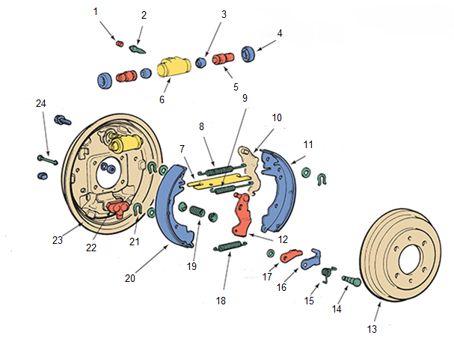

- The brake shoe lining provides friction against the drum to stop the vehicle?

True or False:

- Complete the following statement about drum brake operation using the following words.
Words: Action, Applied, Brake, Direction, Drum, Effectiveness, Force, Important, Multiplies, Pin, Pressing, Rotating, Shoe, Stop, Vehicle
Drum __________ operation is fairly simple. The most __________ feature contributing to the __________ of the braking __________ supplied by the __________ brake is the brake shoe pressure or force directed against the drum. With the __________ moving in either the forward or reverse __________ with the brakes on, the __________ force of the brake shoe __________ against the brake drum increasingly __________ itself (called self-energizing) because the brake’s anchor __________ acts as a brake shoe __________ and prohibits the brake __________ from its tendency to follow the movement of the __________ drum. The result is a wedging __________ between the brake shoe and brake drum. The wedging action combined with the applied brake force creates a self-multiplied brake force.

- All master cylinders are made of cast iron?

True or False:

- The purpose of the master cylinder is to ______.

- Generate the hydraulic pressure needed to apply the brake mechanisms
- Automatically pump the brakes during panic stops
- Supply mechanical force to the brake mechanisms
- All answers are correct

- If the master cylinder has a large rear chamber and a smaller front chamber.

- The large chamber supplies fluid for the rear drum brake
- The large chamber supplies fluid for the front disc brakes
- The vehicle has a dual diagonal split brake system
- The vehicle has four-wheel disc brakes

- An aluminium master cylinder?

- Has a plastic fluid reservoir
- Has an anodised bore
- Is often called a composite master cylinder
- All answers are correct

- What is a tandem master cylinder?

- Name the components of a master cylinder assembly below.
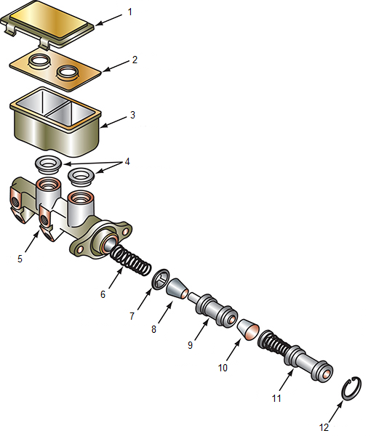

- Complete the following statement about master cylinder function using the following words.
Words: Brakes, Cylinder, Fluids, Force, Hydraulic, Master, Mechanical, Movement, Pressure
The master __________ transmits the __________ on the brake pedal to each of the four-wheel __________ to stop the vehicle. It changes the driver’s __________ pressure on the pedal to __________ force, which is changed back to mechanical __________ at the wheel brake units. The __________ cylinder uses the fact that __________ are not compressible to transmit the pedal __________ to the wheel brake units.

- Identify the two (2) basic types of power-assist unit designs?

- Power assisted brakes are designed with vacuum-assisted units that use engine vacuum?

True or False:

- Power assisted brakes are designed with vacuum-assisted units that use vacuum developed by an external pump?

True or False:

- The function of the nitrogen-charged pneumatic accumulator on a hydraulic brake booster is to _____.

- Prevent power steering fluid from mixing with brake fluid
- Provide reserve power assist pressure if the engine stalls
- Reduce boost pressure when pedal effort is less than 10 psi
- Hold return pressure until the brake pedal is released

- Complete the following statement about booster function using the following words.
Words: Activate, Apply, Assist, Brakes, Developed, Driver, Engine, External, Hydraulic, Mechanisms, Multiply, Pedal, Pistons, Pump, System, Vacuum, Wheel
Power __________ are nothing more than a standard __________ brake system with a booster unit located between the brake __________ and the master cylinder to help __________ the brakes. Two basic types of power-assist __________ are used. The first is __________ assist. These systems use __________ vacuum, or sometimes vacuum pressure developed by an __________ vacuum pump, to help __________ the brakes. The second type of power assist is hydraulic __________. It is normally found on larger vehicles. This __________ uses hydraulic pressure __________ by the power steering __________ or other external pump to help apply the brakes. Both vacuum and hydraulic assist act to __________ the force exerted on the master cylinder __________ by the driver. This increases the hydraulic pressure delivered to the __________ cylinders or calipers while decreasing __________ foot pressure.

- Name the components of a vacuum booster assembly below.
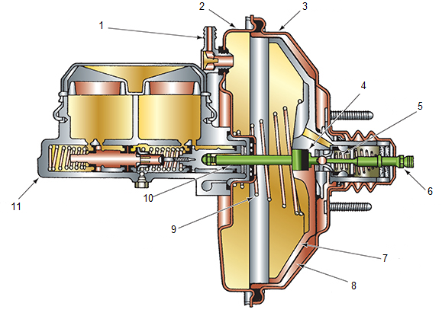

- Name the components of a hydraulic booster assembly below.
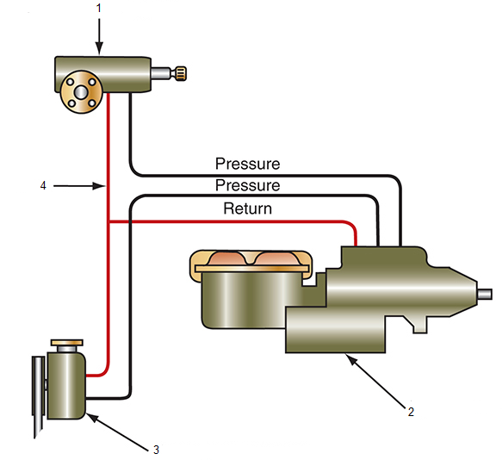

- Complete the following statement about manual park brake function on vehicles fitted with disc brakes using the following words.
Words: Accessible, Apply, Assembly, Brakes, Cables, Carrier, Drum, Manually, Operate, Parking, Plate, Rear, Self-adjuster, Serviced, Shoes, Smaller, Vehicles, Wheel
The rear disc/drum or auxiliary __________ parking brake arrangement is found on some __________ with fixed or sliding calipers. On these __________, the inside of each rear wheel hub and rotor __________ is used as the __________ brake drum. A pair of small brake __________ is mounted on a backing __________ that is bolted to the axle housing or the hub __________. These parking brake shoes __________ independently of the service brakes. They are applied by linkage and __________ from the control pedal or lever. The cable at each __________ operates a lever and strut that __________ the shoes in the same way that __________ drum parking brakes work. The assembly (often called the drum-in-hat system) is a __________ version of a drum brake and is __________ much like any other drum brake. However, they do not have __________. The parking brakes must be adjusted __________ with star wheels that are __________ through the backing plate or through the outboard surface of the drum.

- A rear disc/drum parking brake uses the inside of each rear wheel hub and rotor assembly as a parking brake drum?

True or False:

- Rear disc parking brake have a mechanism that forces the pads against to rotor hydraulically.

True or False:

- The parking brake keeps a vehicle from rolling while it is parked.

True or False:

- The park brake works mechanically, using a lever assembly connected through a cable system to the rear drum service brake.

True or False:

- Electric park brakes, are fitted with a motor solenoid, so there is no need for parking brake cables and linkages.

True or False:

- Complete the following statement about hydraulic brake operation on vehicles fitted with disc brakes using the following words.
Words: Compressible, Decreases, Force, Increased, Lines, Liquid, Master, Measure, Operate, Output, Piston, Pressure, Reliable, Shoes, Size, System, Transmitted
A hydraulic __________ uses brake fluid to transfer __________ from the brake pedal to the pads or __________. This transfer of pressure is __________ and consistent because liquids are not __________. That is, pressure applied to a __________ in a closed system is __________ by that liquid equally to every other part of that system. Apply a __________ of 100 pounds per square inch (psi) (690 kPa) through the __________ cylinder and you can __________ 100 psi (690 kPa) anywhere in the __________ and at each wheel where the brakes __________.
The force can be __________ at the output (i.e., at the wheel) by increasing the __________ of the piston, though piston travel __________. The force at the __________ can be decreased by decreasing the size of the __________, but the piston travel increases.

- Explain the operation of the mechanical braking system?

- Complete the following statement about air over hydraulic braking system operation using the following words.
Words: Axle, Brake, Compressor, Cylinder, Fault, Fluid, Foot, Front, Hydraulic, Lines, Master, Output, Passages, Pressure, Proportions, Protection, Pushes, Reservoirs, Service, Supply, Tank
Compressed air from the __________ is stored in a wet __________ in a semi-dried condition. It then flows to the multi-circuit __________ valve, which divides the feed to serve the two __________ reservoirs. Simultaneously, pressurised air from the __________ combines through internal __________ in the multi-circuit protection valve to operate the remote spring __________ actuator through the hand control valve. Two service __________ are connected to a tandem power __________ controlled by a dual __________ valve. This arrangement maintains air __________ to the other circuit in case of a __________ develops in one service line. The power piston push rod __________ the tandem master cylinder __________ piston forward so that the air __________ is converted to hydraulic pressure. The hydraulic __________ supply is divided into two circuits to serve the __________ and rear brake expander cylinders. A hydraulic load sensing valve is installed in the __________ circuit of rear axle of the tandem __________ cylinder. This valve appropriately __________ the braking effort provided by the rear __________ based on the load carried. This is achieved by modifying the fluid pressure reaching the rear brake cylinders.

- Complete the following statement about air braking system operation using the following words.
Words: Brakes, Compressor, Dependent, Engine, Limits, Operate, Pressure, PSI, Reservoirs, Tubing
Air Brakes require at least 100 psi to __________ correctly. This __________ is provided by a belt-driven air __________, and the compressed air is held in one or two air __________ (tanks). A governor mounted on the compressor __________ the amount of pressure to about 125 __________. The reservoirs and the __________ are connected via steel __________ to a manifold valve (foot valve) usually mounted on the __________ side of the bulkhead. A three-way valve directs the air __________ on the action of the driver.

- Hygroscopic brake fluid absorbs moisture from the air.

True or False:

- DOT 3 brake fluid has a higher boiling point than DOT 4 fluid.

True or False:

- From the image below, explain what the technician is checking for?
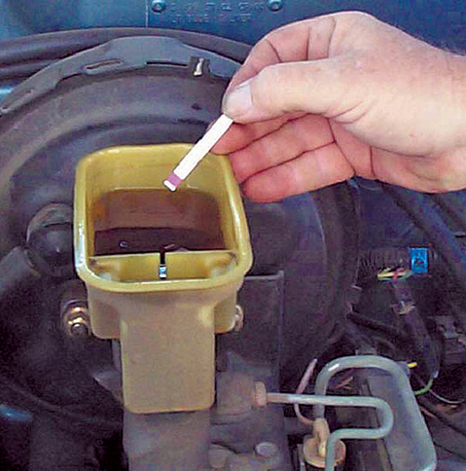

- From the image below, explain what the technician is checking for?
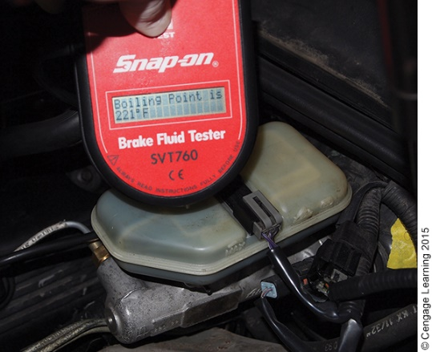

- Brake rotors should be checked for?

- Thickness
- Parallelism
- Runout
- All answers are correct

- A dial indicator is used to measure runout on a disc rotor.

True or False:

- Complete the following statement about brake pad inspection using the following words.
Words: Calipers, Friction, Inspected, Manual, Minimum, Pads, Plate, Replacement, Thinnest
Disc brake __________ should be checked periodically. Some __________ have inspection holes in the caliper body. If they do not, the pads can be __________ from the outer ends of the caliper. If you are not sure the pads are worn enough to warrant __________, measure them at the __________ part of the pad. Compare this measurement to the __________ brake pad lining thickness listed in the service __________, and replace the pads if needed. Typically, if the __________ material remaining on the backing __________ is less than 1/8 inch (3.175 mm), the pads should be replaced.

- From the image below, explain what the technician is checking for?
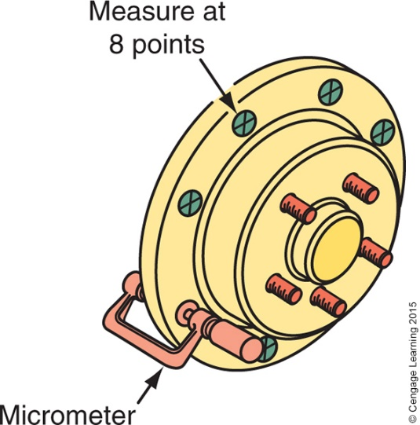

- Drum brake linings should be replaced when linings are?

- Worn to within 1/32 inch (.8mm) of the rivet head
- Contaminated with oil or grease
- Contaminated with brake fluid
- All answers are correct

- List five (5) types of wear to look for when inspecting brake drums?

- When must a wheel cylinder be replaced?

- Most automotive manufacturers recommend charging the brake fluid periodically.

True or False:

- When bleeding a dual diagonal split brake system, the bleeding sequence is usually _____.

- LR-RR-RF-LF
- RF-LF-LR-RR
- RR-LF-LR-RF
- LR-RF-RR-LF

- While manually bleeding a brake system, loosens all the brake bleeder screws at the same time.

True or False:

- Explain why bleeding air out of a hydraulic system is important.

- Complete the following statement about drum brake adjustment using the following words.
Words: Adjustment, Brake, Centre, Designs, Drum, Expanding, Installed, Specified, Supported, Wheels
Perform manual __________ adjustments with the vehicle __________ on a hoist or stands and off the ground so that the __________ can rotate during adjustment. Exact __________ procedures are different for different brake __________ but all are based on the principle of __________ the shoes until they contact the __________ and then backing off the adjustment a __________ amount. With the brakes adjusted and the drum __________, pump the pedal once or twice to __________ the shoes. Recheck the brake adjustment.

- Complete the following statement about park brake adjustment using the following words.
Words: Adjustment, Brake, Clearance, Holds, Make, Manufacturer, Parking, Release, Spin, Vehicle
Parking brake testing and __________ procedures vary with the vehicle __________. A common test is to raise the __________ off the ground and apply the __________ a specific number of “clicks.” Once the brake is set, attempt to __________ the rear wheels. If the wheels spin, __________ the parking brake and check the rear shoe-to-drum __________ and adjust if necessary. Recheck the __________ brake. If the wheels still spin, adjust the parking brake until the brake __________. Release the brake and __________ sure the wheels spin and the brakes are not dragging.

- After brake pad replacement, what is the first thing the technician should do when the vehicle is lowered?

- Consider the various checks that you would make after servicing brakes?

- Which source of information will give you the most detail about inspecting and servicing brakes on the vehicle you are working on?

- Workshop manual
- Owner’s manual
- Google
- Textbooks

- Why is it very important that the Job Card is completed correctly?

