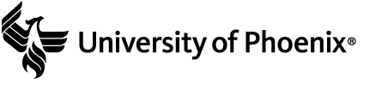

Manage Your Health, Inc. Case Study
Manage Your Health, Inc. (MYH) is a Fortune 500 company that provides a variety of healthcare services across the globe. MYH has more than 20,000 full-time employees and more than 5,000 part-time employees. MYH recently updated its strategic plan; key goals include reducing internal costs, increasing cross-selling of products, and exploiting new Web-based technologies to help employees, customers, and suppliers work together to improve the development and delivery of healthcare products and services. Below is an idea the IT department has developed for supporting these strategic goals:
Recreation and Wellness Intranet Project: Provide an application on the current intranet to help employees improve their health. A recent study found that MYH, Inc. pays 20 percent more than the industry average for employee healthcare premiums, primarily due to the poor health of its employees. You believe that this application will help improve employee health within 1 year of its rollout so you can negotiate lower health insurance premiums, providing net savings of at least $30/employee/year for full-time employees over the next 4 years. This application would include the following capabilities:
- Allowing employees to register for company-sponsored recreational programs, such as soccer, softball, bowling, jogging, and walking
- Allowing employees to register for company-sponsored classes and programs to help them manage their weight, reduce stress, stop smoking, and manage other health-related issues
- Tracking data on employee involvement in these recreational and health-management programs
- Offering incentives for people to join the programs and do well in them (e.g., incentives for achieving weight goals, winning sports team competitions, etc.)
Assume that the project will take 6 months to complete and cost about $200,000.

