Pre-Review Disclaimer: Please note that my comments are not all inclusive for this pre-review. Pre-Reviews are completed in about 15-minutes of my time and do not have the lengthy review (about 45-minutes to an hour) that a final paper might have from me. You are not exempt from new issues found during the more thorough review. The early review though, provides the individual a good feeling towards how well their paper was assembled! This review does not perform a Turnitin check. Fix all of the content BEFORE submitting your final paper. If you have any questions about this feedback, follow-up questions must occur via a phone call where we both have the paper in front of us to discuss (no further emails please).
Here are some high-level thoughts:
- You have a serious problem, this does not follow the template. You must download the template and KEEP ALL of the subject headers as they provide your organization.
- Indent the first line of each paragraph five spaces. See Written Assignment Requirements below.
- See comments.
None of your sources are CITED within the paper itself. That results in ZERO sources used. This is a stellar video on APA citations…
Whenever you use a source, you must have an in-text citation and a reference citation. They're a matched pair--like shoes or gloves. What are the differences between an APA in-text citation and an APA reference citation? How do the two work together? See this video:
VIDEO on citations in APA =
https://www.youtube.com/watch?v=LbyJdMz-Ato
- See reference page that needs work.
- Make sure to have ten pages for your paper. If you have nine pages for example, the best you can do is 90% on the final paper.
Thank you for the opportunity to pre-review! If I can help, I am a phone call away (352-596-2088 - Office Hours – DAILY from 10:00 a.m. - 4:00 p.m. EST or by appointment in advance).
Dr. McFaul
WRITTEN ASSIGNMENT REQUIREMENTS
I expect that ALL papers should adhere to APA compliance...and that includes the following:
- NO PDF FILES - all papers must be submitted in Microsoft Word
- USE THE TEMPLATES UNDER DOC SHARING
- Times New Roman 12 Font
- Double-Spacing
- One Inch Margins
- And more...using the 6th Edition as our guide.
- Your reference list and your citations must match exactly.
- Only work submitted in our classroom will count towards a grade – no emailing of papers – all must be submitted in the classroom!
In addition, I expect the following in your writing style this semester:
- Use subject headers for all papers - your reader appreciates and expects that level or organization to your work!
- Two spaces after each period for ease of reading
- Use zero point line spacing with DOUBLE SPACING.
- All online sources MUST include the web link where the exact article can be found! NO HOME PAGES – minus points if this is not provided in the reference page.
- No extra blank lines between sections – deliver a tight paper.
- No contractions
- Indent the first sentence of a new paragraph five spaces.
- No visuals in the paper itself – include in the Appendix for Final Group Paper & exams
- No “I” statements – do not write in first person
- Numbers one through nine within your paper should be written out if used within the text of your paper
- Reference page must have a URL for all online sources. Zero points given for sources listed that do not have this.

NOTIFICATION TO ALL TEAM MEMBERS – WEEK SIX ASSIGNMENT
My clear expectation to each and every one of you is that you must deliver a portion equal to three pages or more (whatever is needed to meet the page count) of the final paper AND you must prove to me that you have done so! By the end of week six, I want you to send me your contribution VIA email. This is done individually. Then your group will have Week Seven to edit and prepare your final paper.
Let us be clear – by the end of Week Six EMAIL me YOUR INDIVIDUAL contribution to the group. The benefit for you is that I will correct any APA, spelling, or other errors that you might have to help you achieve a good final group grade!
Again, send me 3 to 3.5 pages of the final paper and you must submit at least two authored sources. Divide the paper up and build in redundancy of assigning sections so that you are ensured that all sections will be completed. If you get down to two members (which some groups may) you are then expected to deliver five pages each.
Your final grade will be based on your contributions. Not all group members will get the same grade if it is obvious that they did not take this assignment seriously and contribute MORE than their share. This is not a group project that you can rely on others to do YOUR work!
Remember, I am here to help if you have any questions or need help generally with the assignment – I want to see you succeed!

Dr. McFaul

Consultancy Work
Saint Leo University

The company of choice
indentIn this report, the company of choice for the consultancy work is The Coca-Cola Company. I have chosen this company from the perspective that Coca-Cola is a brand that is continuing to transform the world through many activities both through CSR. The company has immensely improved or touched many people’s lives through employment, bringing products that make life sweet, beverages, and water.
In terms of CSR, the company has installed water projects, solar energy, and environmental care for communities around the world through its various foundations. The company continues to donate food and basic social amenities to communities that are hit by disasters which gives it a cutting edge relationship with the communities that are their immediate customers.
My consulting objectives
INDENTWhen working for Coca-Cola I have a few objectives that I intend to ensure are achieved. First is employee career growth and development. Well, the company hires the top of the cream qualified personnel who have been able to propel the brand to the great heights it is at now. However, the company needs to develop its employees such that they are able to grow career wise. Am intending to create an impact on the new, junior, as well as lowly qualified staff. Such staffs tend to have less attention from the company's top management in terms of growth and development since they are under the watch of strict supervisors and managers who want to see them delivering and meeting the targets.
Hence changing such is working on a plan with Coca-Cola to see that either the company is able to partner with colleges that are able to accommodate the junior staff to offer them pieces of training on business management, production, inventory supplies, and logistics management. This will give a great opportunity to such employees to get more academic prowess to stand a chance for job promotions.
About Coca-Cola
Coca-Cola has been commonly known to be a beverage company with beverage brands like coke, diet coke, Fanta, sprite, and even Dasani drinking water. However, the company has other brands associated with it. Actually, the company has over 280 products in over 200 countries
Goals and objectives of Coca-Cola
The company's goals are to maximize the profits while maintaining a long term sustainable growth within the markets. Coca-Cola looks at partnering with other companies in the delegation of its duties like bottling. This will ensure that it improves its production as well as marketing strategies while the partners work on product distribution and presentation.
The key target audience for Coca-Cola products includes the young and the youth of both genders. Men drink Coca-Cola beverages just like women.
The business model
The company sells syrup to other bottling companies that are tasked to complete the manufacturing and distribution of the final products to the list of consumers. On the other hand, the company makes money from the sale of beverages to retailers, wholesalers, as well as distributors.
Main competitors
In any business settings, the ability for a company to reach the last mile customer as well as stay afloat depend on how strategic it is. Coca colas main competitors include other beverage manufacturers that include; Keurig Dr. Pepper, Tropicana, PepsiCo, PepsiCo, and red bull. Amongst these, PepsiCo is the main rival to Coca-Cola as the rest comes forth.
Competitive advantages and limitations relative to the key competitors
To win over billions of youths drinking or using Coca-Cola products, the company has had the following competitive advantages; brand equity, global presence, pricing strategy, product portfolio, and marketing just to look at a few.
However, its limitations include; it receives very aggressive marketing competition from Pepsi, despite the company having thousands of products internationally, the company has a low product diversification and the company is facing a lot of pullbacks from its customers who are concerned about the healthy nature of Coca-Cola products.
Social medic activities
The company has intensified its social media activities in regards to branding as well as product awareness. The company has a social media presence on YouTube, Twitter, blogs, websites, and Instagram. The company has actively worked on updating its social media posts while making the message consistent as well as brand identity.
YouTube
In YouTube, the company has already made a Christmas 2020 commercial that is aimed at ushering its consumers into the festive season. https://www.youtube.com/watch?v=yg4Mq5EAEzw

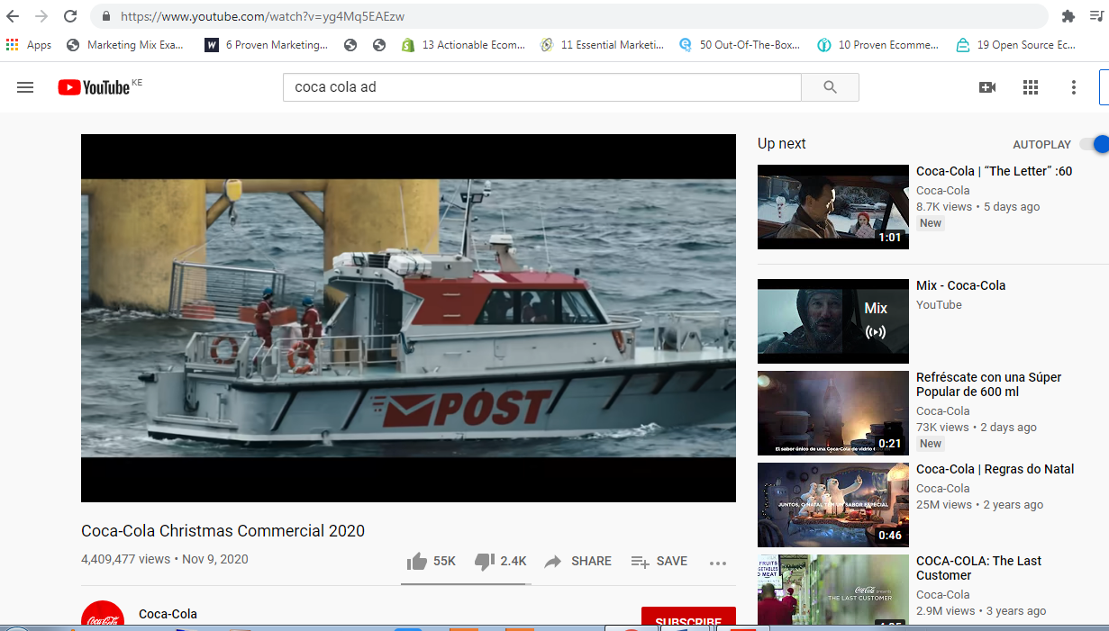
In Twitter, the company constantly updates its corporate dealings and operations on its Twitter account. The company shares amazing happy moments in life on its Instagram page.
Looking at its corporate website, https://www.coca-colacompany.com/, the company has made access to critical company data very easy. The navigation is superb as items like about the company, the brands, careers, and investor relations are conspicuously displayed. The blog section menu is also available on the header menu thus visitors are able to understand the happenings in the company very well and so easily.
Improvement of social media activities
Improvement should be done in regards to its Twitter marketing whereby the products should be featured most of the time. The other social media handles like YouTube and Instagram as well as the corporate websites and blog are well handled and organized.
Twitter message
Dull foods are never dull, it’s just that you have missed one ingredient, we know the ingredient, and it’s right in the next shop near you. Buy a coke and make the food fancy. #liveonthecokesideoflife #cocacola #openacokeopenhappiness.
The corporate website has to be made search-friendly, the search function on the website has to be made to have search suggestions or autocomplete based on the words being entered on the search bar.
Blog
The blog, www.coca-colacompany.com/news does not load very fast. This is disgusting for people who are looking for critical information and do not have much time to wait for the content to load. The company has to come up with content creators who are able to write articles that talk about the brand. This would help in search engine marketing where people searching for information are able to land on the Coca-Cola website and learn more about this great company.
Blog message
Coca-Cola to offer education to rural homes
As part of the company’s strategy to give back to society in a better way, the company is rolling out a program to offer subsidized access to education for rural communities. The company will fund the construction of a computer lab in each school and fully equip the classrooms with twenty computers. The company is counting on the rolled out solar power projects to propel the computer classrooms. This project is to be rolled out in 800 schools as from 2021. Beneficiaries will be school going children and students who are waiting to join their higher institutions of learning.

References
Besanko, D. (2010). Economics of strategy. Hoboken, NJ: John Wiley & Sons.
Kent, M. (2011). Coca-Cola.
Labitan, B. (2012). Moats: The competitive advantages of Buffett & Munger businesses. United States: Lulu.com.

I know that this was shared with you before – you have to have an in-text citation OR the source does not count.
This is in your syllabus:
This is a stellar video on APA citations…
Whenever you use a source, you must have an in-text citation and a reference citation. They're a matched pair--like shoes or gloves. What are the differences between an APA in-text citation and an APA reference citation? How do the two work together? See this video:
VIDEO on citations in APA =
https://www.youtube.com/watch?v=LbyJdMz-Ato

