Homework 7

- Compare and contrast the basic TTL inverter in Figure 1 with corresponding RTL and DTL counterparts

Figure 1 (Basic TTL Inverter)
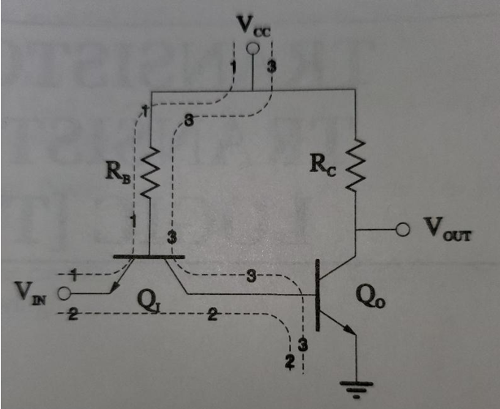

- Compare and contrast the basic TTL NAND in Figure 2 with the corresponding DTL Design

Figure 2 (Basic TTL NAND Gate)
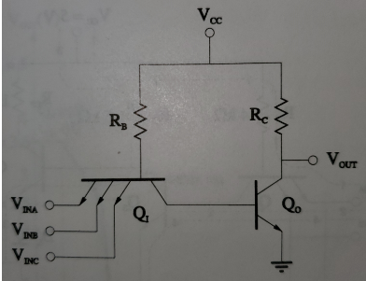

- For the basic TTL inverter of Figure 1, determine
I_{IN}, l_{RB}, I_{B,O} and I_{RC} for the following conditions:
V_{IN}= 0 V
Let β_{F}= 100, β_{R} = 0.05, V_{BE}(FA) = V_{BC}(RA) = 0.7 V, V_{BE}(SAT) = 0.8 V, and V_{CE}(SAT) = 0.2 V for the BJTs.

- For the basic TTL inverter of Figure 1, with V_{CC} = 5 V, determine
I_{IN}, l_{RB}, I_{B,O} and I_{RC} for the following conditions:
V_{IN}= 0 V
Let β_{F} = 100, V_{BE}(FA) = V_{BC}(RA) = 0.7 V, V_{BE}(SAT) = 0.8 V, and V_{CE}(SAT) = 0.2 V for the BJTs.

- For the standard TTL NAND gate of Figure 3, calculate the following:

- the input low current I_{IL}
- the output low current l_{OL}
- the maximum fan-out ≡ N = I_{OL}/I_{IL}
- the average power dissipation

Use βF = 70, βR = 0.05, V_{BE} (FA) = 0.7 V, V_{BE} (S AT) = 0.75 V,
V_{BC}(RA) = 0.7 V, and V_{CE}(SAT) = 0.15 V.
Use σ₀ = 0.8 for the output low state.

