Final Exam
Instead of floating point arithmetic, it is recommended to do arithmetic with fractions. Solve the problems using the methods you learned in class (Optional ways you google will not earn any point).

NAME:
SIGN:
Total: /25

1-1 | 1-2 | 1-3 | 1-4 | 1-5
/0 | /2 | /2 | /2 | /3

2-1 | 2-2 | 2-3 | 2-4 | 3-1
/2 | /2 | /2 | /3 | /3

3-2
/4

1. We are solving the max flow problem.
1-1. (0 point) The initial flow is as follows with the flow value = 3.
Variable | Value
x_{s1} | 1
x_{s3} | 2
x₁₂ | 0
x₁₄ | 1
x₃₂ | 2
x₃₄ | 0
x_{2t} | 2
x_{4t} | 1
Flow Value = | 3
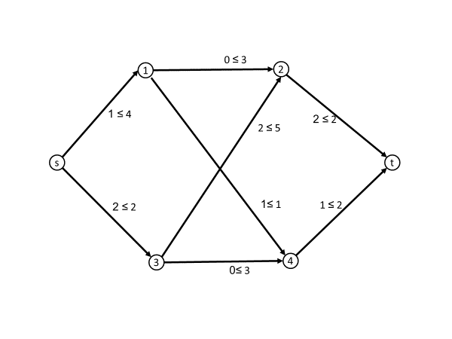

1-2. (2 points) The residual network of the flow in 1-1 is illustrated as follows. Fill in the residual capacities in the table. Overdraw an augmenting path with the solid lines. What is the capacity of the augmenting path?
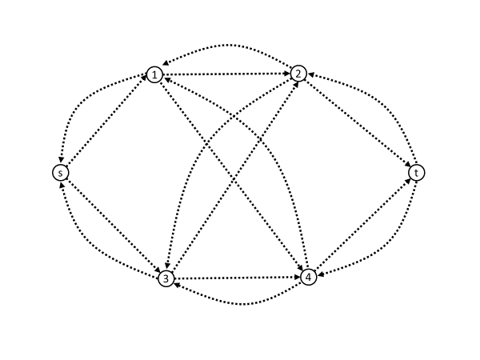

Arc | Residual Capacity |  | Arc | Residual Capacity
(s,1) |  |  | (1,s)
(s,3) |  |  | (3,s)
(1,2) |  |  | (2,1)
(1,4) |  |  | (4,1)
(3,2) |  |  | (2,3)
(3,4) |  |  | (4,3)
(2,t) |  |  | (t,2)
(4,t) |  |  | (t,4)
Capacity of the augmenting path = .

1-3. (2 points) What is the new flow augmented by the path flow in 1-2? (Fill in the blanks in the table on the right.) And, what is the new flow value?
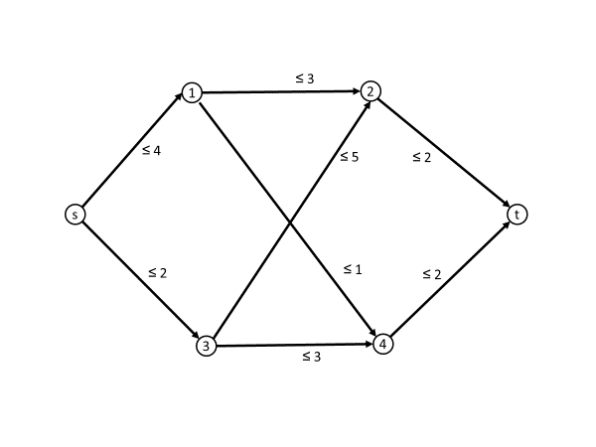
Variable | Value
x_{s1}
x_{s3}
x₁₂
x₁₄
x₃₂
x₃₄
x_{2t}
x_{4t}
Flow Value =

1-4. (2 points) Fill in the blanks of the table with the residual capacities on the residual network of the new flow.

Arc | Residual Capacity |  | Arc | Residual Capacity
(s,1) |  |  | (1,s)
(s,3) |  |  | (3,s)
(1,2) |  |  | (2,1)
(1,4) |  |  | (4,1)
(3,2) |  |  | (2,3)
(3,4) |  |  | (4,3)
(2,t) |  |  | (t,2)
(4,t) |  |  | (t,4)

1-5. (2 points) Certify with a cut (S, T), s $∈$ S and t $∈$ T, that the new flow is optimal. Explicitly write the nodes of S and T, and overdraw the cut edges with solid lines on the figure. What is the cut capacity?

Answer: S = { }, T = { }, Cut Capacity = .

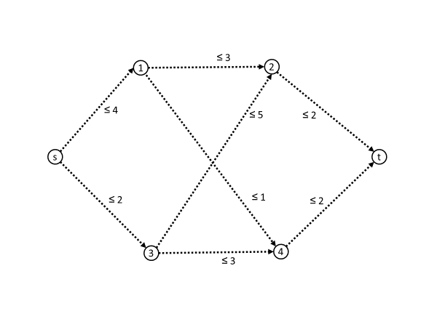

2. Perform the network simplex method to solve the minimum cost network flow problem beginning with the initial basis B = {x_{s2} = 3, x_{2t} = 3, x_{1t} = 5, x_{3t} = 4}. The non-basic variables are x_{s1} = 5 and x_{s3} = 4, x₂₁ = 0 and x₂₃ = 0. In every iteration, dual variable π_{s} = 0.
2-1. (2 points) Overdraw the initial basic arcs with the solid lines in the following figure. Calculate and write the dual variables. Calculate and write the reduced costs of the non-basic variables.

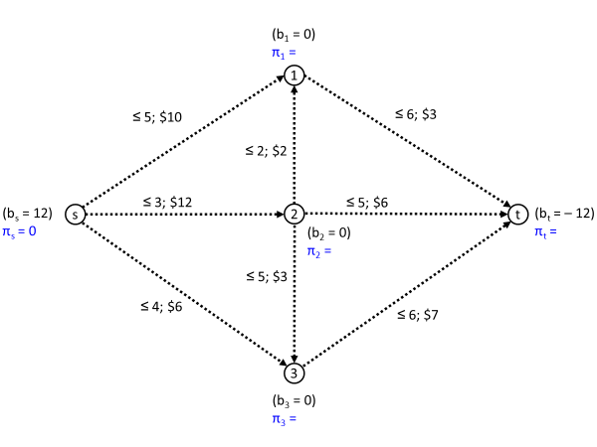
Dual variable | Value
π_{s} | 0
π₁
π₂
π₃
π_{t}

Non-basic variable | Value | Reduced cost
x_{s1} | 5
x_{s3} | 4
x₂₁ | 0
x₂₃ | 0

2-2. (2 points) Is the initial basis optimal? Circle (Yes/No) If No, overdraw with solid arcs the cycle along which the circular flow θ flows in the figure and fill in the blanks in the table.
Variable | Value | Basic/non-basic (B/N?) | Reduced Cost | Check the entering arc  ( v ) | Value update over the cycle  (old ± θ = new) | Check the leaving arc and  write the value of θ
x_{s2} | 3 | B | 0
x_{2t} | 3 | B | 0
x_{1t} | 5 | B | 0
x_{3t} | 4 | B | 0
x_{s1} | 5 | N
x_{s3} | 4 | N
x₂₁ | 0 | N
x₂₃ | 0 | N

2-3. (2 points) Overdraw the basic arcs with the solid lines in the following figure. Calculate and write the dual variables. Calculate and write the reduced costs of the non-basic variables.

Dual variable | Value
π_{s} | 0
π₁
π₂
π₃
π_{t}

Non-basic variable | Value | Reduced cost

2-4. (2 points) Is the basis optimal? Circle (Yes/No) If No, overdraw with solid arcs the cycle along which the circular flow θ flows in the figure and fill in the blanks in the table.
Variable | Value | Basic/non-basic (B/N?) | Reduced Cost | Check the entering arc  ( v ) | Value update over the cycle  (old ± θ = new) | Check the leaving arc and  write the value of θ
x_{s2}
x_{2t}
x_{1t}
x_{3t}
x_{s1}
x_{s3}
x₂₁
x₂₃

3. Consider the assignment problem with the following cost matrix C = ( c_{ij} ), where c_{ij} is the cost to assign worker i to job j.
5 8 7 3 2
4 3 3 7 5
4 8 5 3 3
3 6 5 2 5
2 7 5 6 8

3-1. (3 points) Explicitly write down an LP formulation of the assignment problem.

3-2. (4 points) Solve the problem using Excel Solver and submit your Excel Worksheet.

